Instructions for Updating the OpenSpecimen JSON file
By Kenneth Watanabe, PhD
A default master OpenSpecimen JSON file can be downloaded from the following link https://openspecimen.atlassian.net/wiki/x/BIBlBQ.
The master OpenSpecimen JSON file has 3 main sections
- Dictionary – This section controls the participant, visit and specimen fields that get displayed during specimen creation.
- Participant-list-view – This section controls the columns that are displayed in the participant list.
- Specimen-list-view – This section controls the columns that are displayed in the specimen list.
Additional sections can be added to the JSON file
- specimenCollection – This section allows data entry of additional fields (including custom fields) during specimen collection.
- rde – This section enables Rapid Data Entry

The link below gives examples on how to modify the JSON file.
https://openspecimen.atlassian.net/wiki/spaces/CAT/pages/101187680/Attribute+types+examples

Instructions for adding a custom field to specimen data entry
The following section shows how to add the custom specimen field “Processing Procedure” defined in the “Specimen Form” form. This is a dropdown field that is only displayed if the specimen type is neither “Buccal swab” or “Whole Blood”. Notice the tag name DD11 in the name field. The DD11 tag links to the dropdown options available and I will show where to find the DD11 tag later in this document.
{
"name": "specimen.extensionDetail.attrsMap.DD11",
"caption": "Processing Procedure",
"type": "dropdown",
"optional": false,
"defaultValue": "Liquid Nitrogen",
"listSource": {
"apiUrl": "forms/permissible-values",
"selectProp": "value",
"displayProp": "value",
"queryParams": {
"dynamic": {},
"static": {
"formName": "SpecimenForm",
"controlName": "DD11" }
}
},
"showIf": {
"op": "AND",
"rules": [
{
"field": "specimen.type",
"op": "!=",
"value": "'Buccal swab'"
},
{
"field": "specimen.type",
"op": "!=",
"value": "'Whole Blood'"
}
]
}
},
The “Processing Procedure” field is a custom specimen field defined in the “Specimen Form” form. Below is a screenshot of the Specimen Form and its controls.
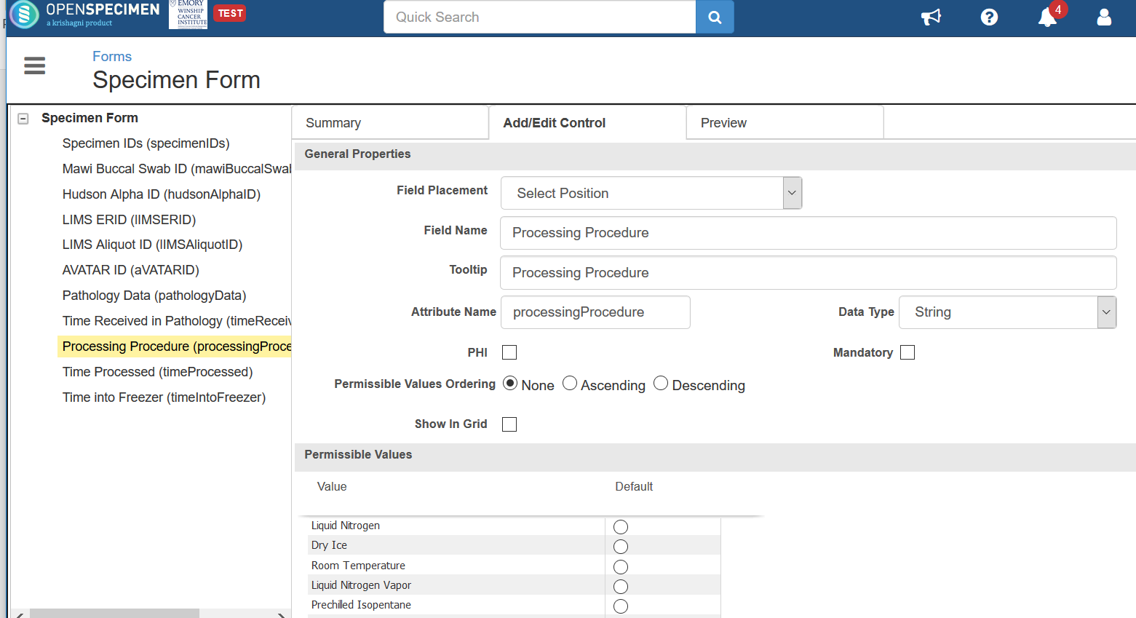
The form is associated to a Collection Protocol at the “Specimen Custom Fields” level.
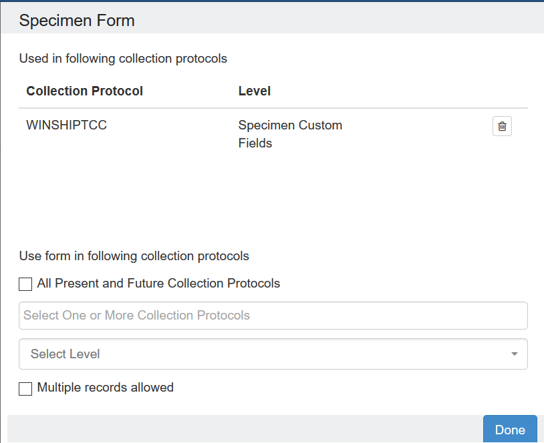

The XML tag of the “Processing Procedure” field is necessary to add the field specimen data entry screen. To find the XML tag, click on the “Export” button from the Summary tab of the form.
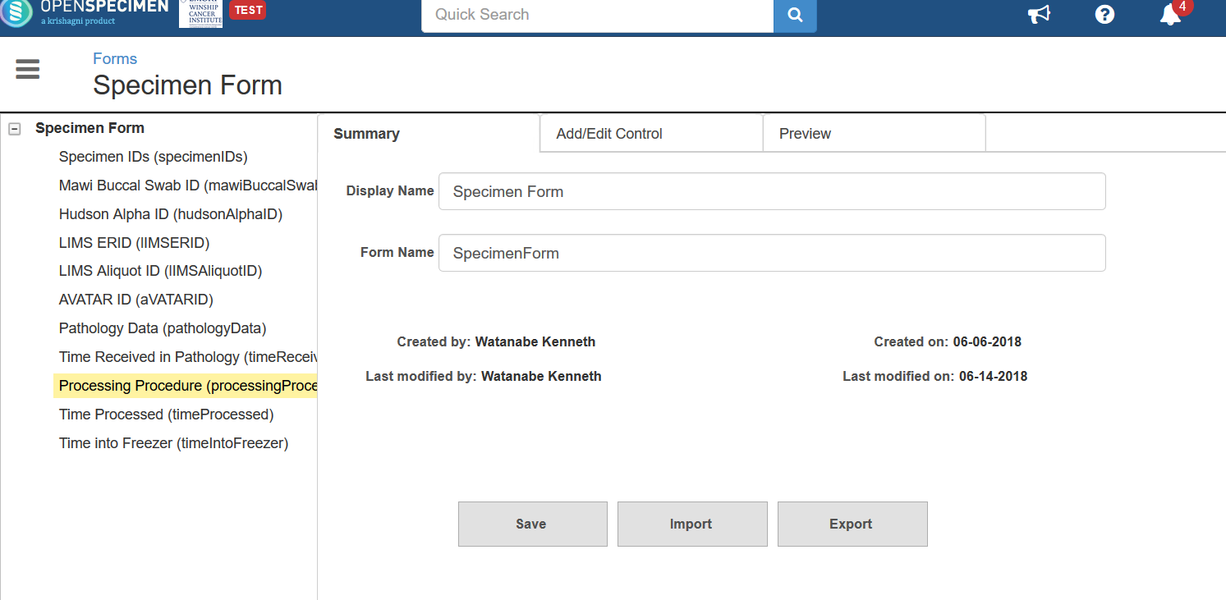
Save the export file and then open it in WordPad. Scroll down to the “Processing Procedure” section. Between the <name> tags is the XML tag DD11. This is the tag that must be entered into the JSON file so that the field will appear in the specimen data entry screen.
<row>
<dropDown>
<name>DD11</name>
<udn>processingProcedure</udn>
<caption><![CDATA[Processing Procedure]]></caption>
<phi>false</phi>
<mandatory>false</mandatory>
<toolTip><![CDATA[Processing Procedure]]></toolTip>
<showLabel>true</showLabel>
<showInGrid>false</showInGrid>
<options>
<option>
<value><![CDATA[Liquid Nitrogen]]></value>
</option>
<option>
<value><![CDATA[Dry Ice]]></value>
</option>
<option>
<value><![CDATA[Room Temperature]]></value>
</option>
…

Note: If a custom field is not appearing or values entered in the field are not getting stored, make sure the custom field is on the correct form. Sometimes the field with the same name exists on different forms.

Instructions for implementing a JSON file
To implement a JSON file across all collection protocols, select the “Settings” tile from the OpenSpecimen home screen. Type “system workflows” into the search bar. Update the “System Workflows” property to point to your custom JSON file. You will have to log out and log back in to pick up the changes.
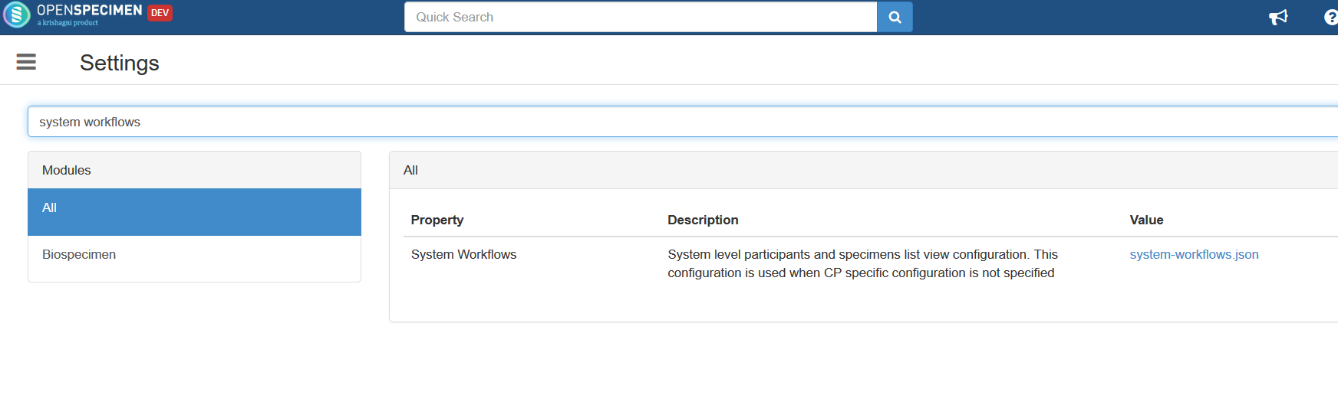
It may be the case that you do not wish to implement the JSON file to all collection protocols but rather a specific collection protocol. Below are instructions to associate a JSON file to a particular collection protocol.
The first step is to get the identifier of the collection protocol that you wish to associate with the JSON file. To do this, go to the dashboard of the collection protocol. Notice that in the address bar, there is an integer after /cp-view/. This number is 128 in the example below.
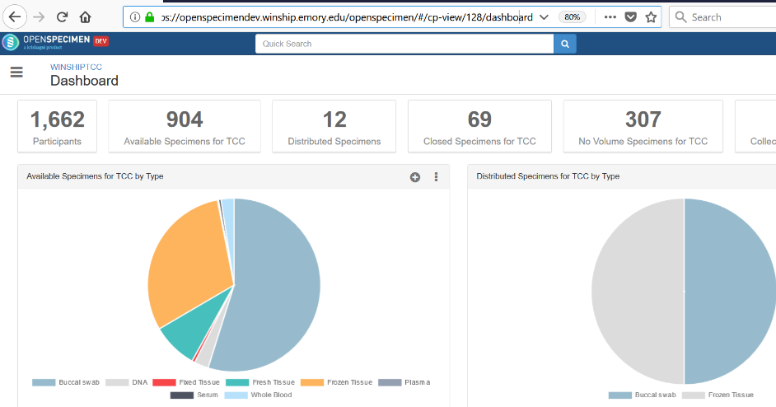
Go to the OpenSpecimen home screen and click on the “Extras” button.
Then click on the “REST API Invoker” button.
Select the “Put” radio button.
For the “Resource URI” enter “rest/ng/collection-protocols/128/workflows”
The number 128 is the protocol number with which we want to associate with the JSON file.
In the “Request Body”, paste the contents of the custom JSON file.
Click on the “Send” button.
If everything is good, you should get a message that says “Status 200: ok”
Refresh your browser and the new JSON file should now go into effect.

